附件：
小港码头（渔业公司区域）规范提升项目宗海图及顶点坐标
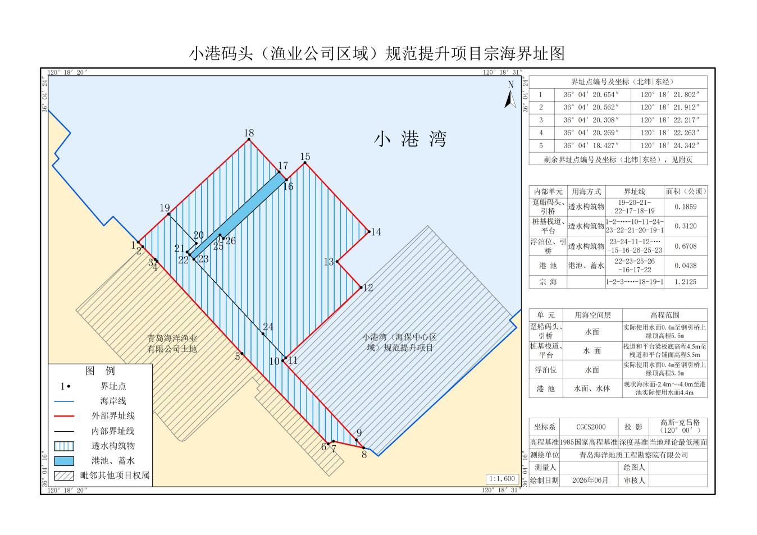
坐标系：CGCS2000
序号 | 北纬 | 东经 | 序号 | 北纬 | 东经
1 | 36°04′20.654″ | 120°18′21.802″ | 14 | 36°04′20.848″ | 120°18′27.479″
2 | 36°04′20.562″ | 120°18′21.912″ | 15 | 36°04′22.231″ | 120°18′25.906″
3 | 36°04′20.308″ | 120°18′22.217″ | 16 | 36°04′21.889″ | 120°18′25.451″
4 | 36°04′20.269″ | 120°18′22.263″ | 17 | 36°04′22.049″ | 120°18′25.269″
5 | 36°04′18.427″ | 120°18′24.342″ | 18 | 36°04′22.700″ | 120°18′24.528″
6 | 36°04′16.618″ | 120°18′26.454″ | 19 | 36°04′21.213″ | 120°18′22.546″
7 | 36°04′16.670″ | 120°18′26.585″ | 20 | 36°04′20.625″ | 120°18′23.227″
8 | 36°04′16.536″ | 120°18′27.327″ | 21 | 36°04′20.455″ | 120°18′23.000″
9 | 36°04′16.693″ | 120°18′27.147″ | 22 | 36°04′20.398″ | 120°18′23.065″
10 | 36°04′18.278″ | 120°18′25.344″ | 23 | 36°04′20.309″ | 120°18′23.166″
11 | 36°04′18.335″ | 120°18′25.418″ | 24 | 36°04′18.818″ | 120°18′24.860″
12 | 36°04′19.734″ | 120°18′27.277″ | 25 | 36°04′20.793″ | 120°18′23.812″
13 | 36°04′20.254″ | 120°18′26.686″ | 26 | 36°04′20.722″ | 120°18′23.894″

