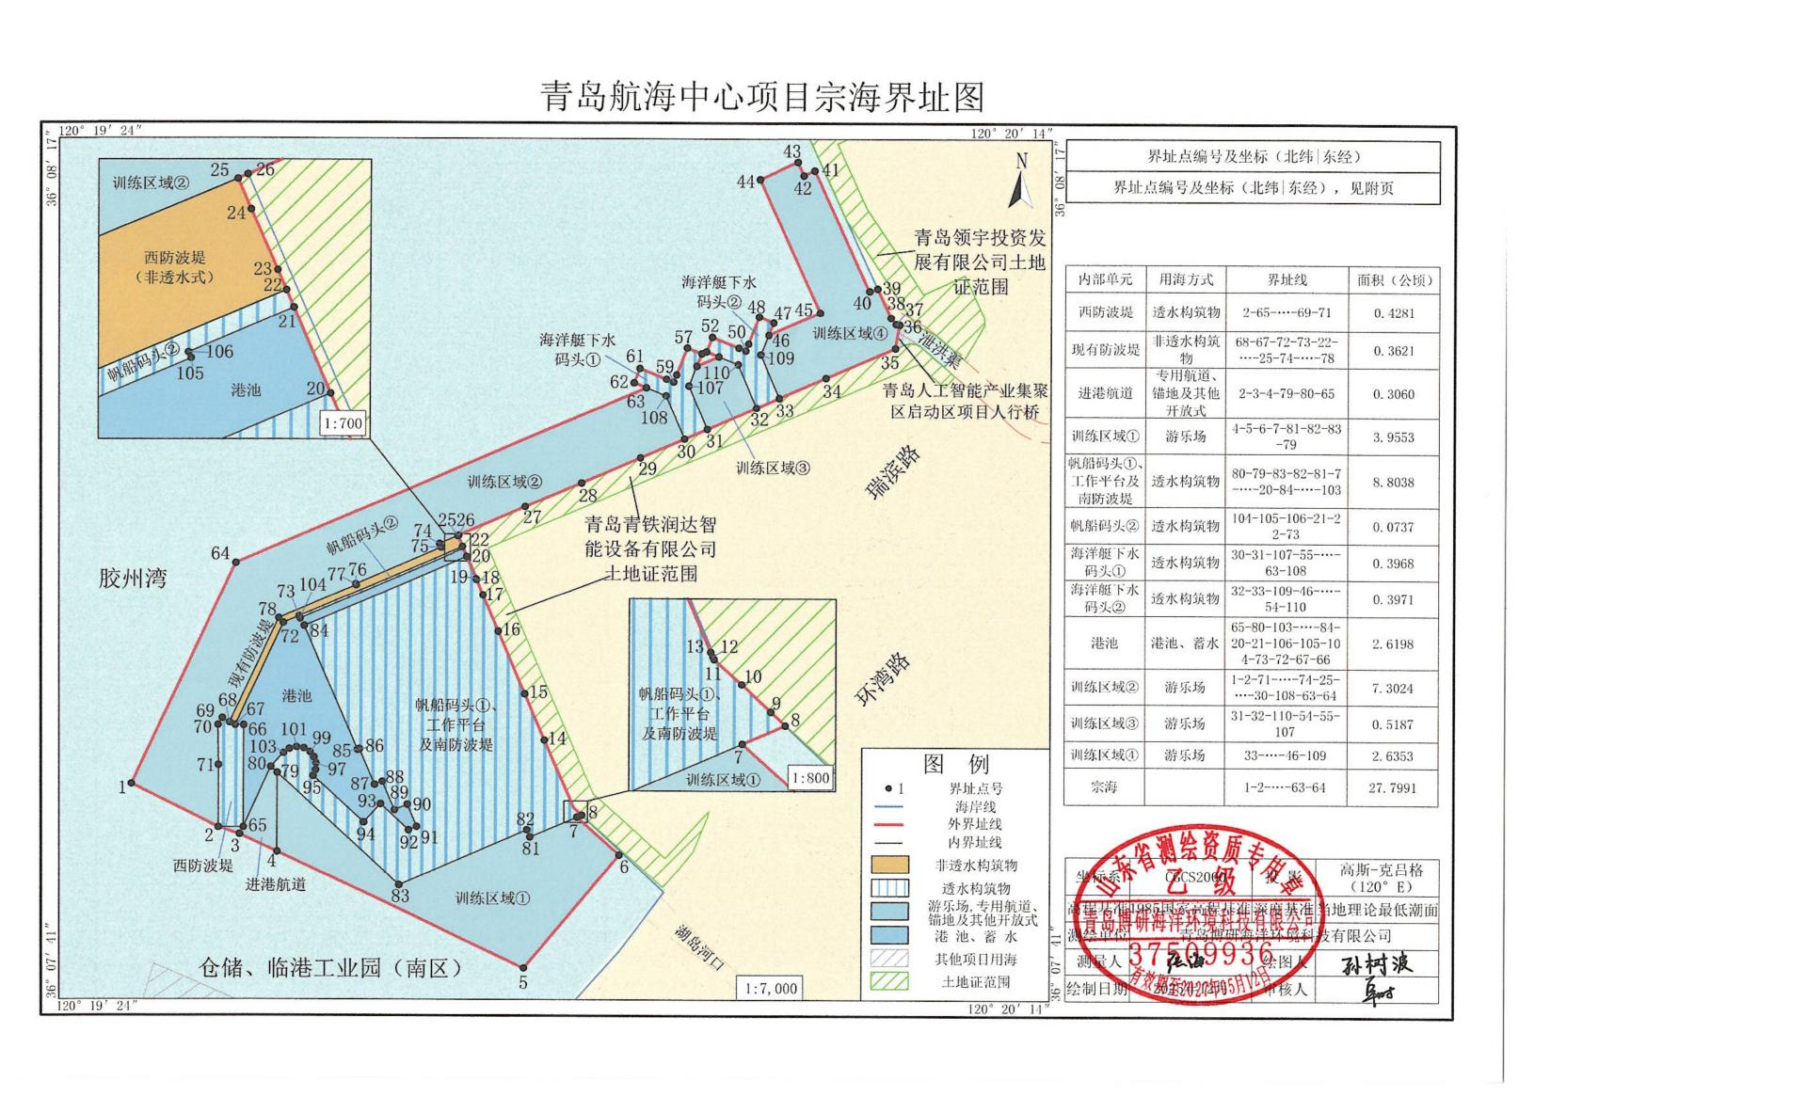

青岛航海中心项目外围界址点
界址点编号及坐标（北纬|东经）
1 | 36°07′50.181″ | 120°19′27.284″ | 41 | 36°08′15.688″ | 120°20′02.393″
2 | 36°07′48.358″ | 120°19′31.713″ | 42 | 36°08′15.487″ | 120°20′01.831″
3 | 36°07′48.065″ | 120°19′32.791″ | 43 | 36°08′16.056″ | 120°20′01.526″
4 | 36°07′47.328″ | 120°19′34.708″ | 44 | 36°08′15.332″ | 120°19′59.559″
5 | 36°07′42.449″ | 120°19′47.403″ | 45 | 36°08′09.761″ | 120°20′02.681″
6 | 36°07′47.165″ | 120°19′52.280″ | 46 | 36°08′08.840″ | 120°20′00.013″
7 | 36°07′48.742″ | 120°19′50.122″ | 47 | 36°08′09.361″ | 120°20′00.271″
8 | 36°07′48.827″ | 120°19′50.372″ | 48 | 36°08′09.603″ | 120°19′59.529″
9 | 36°07′48.891″ | 120°19′50.288″ | 49 | 36°08′08.481″ | 120°19′58.972″
10 | 36°07′49.020″ | 120°19′50.120″ | 50 | 36°08′08.188″ | 120°19′58.827″
11 | 36°07′49.137″ | 120°19′49.958″ | 51 | 36°08′08.306″ | 120°19′58.466″
12 | 36°07′49.150″ | 120°19′49.950″ | 52 | 36°08′08.757″ | 120°19′57.083″
13 | 36°07′49.172″ | 120°19′49.938″ | 53 | 36°08′08.155″ | 120°19′56.784″
14 | 36°07′51.959″ | 120°19′48.471″ | 54 | 36°08′07.946″ | 120°19′57.425″
15 | 36°07′53.881″ | 120°19′47.466″ | 55 | 36°08′07.551″ | 120°19′56.280″
16 | 36°07′56.501″ | 120°19′46.094″ | 56 | 36°08′08.070″ | 120°19′56.537″
17 | 36°07′58.015″ | 120°19′45.302″ | 57 | 36°08′08.312″ | 120°19′55.795″
18 | 36°07′58.653″ | 120°19′44.967″ | 58 | 36°08′07.192″ | 120°19′55.239″
19 | 36°07′58.654″ | 120°19′44.967″ | 59 | 36°08′06.897″ | 120°19′55.093″
20 | 36°07′59.617″ | 120°19′44.462″ | 60 | 36°08′07.015″ | 120°19′54.729″
21 | 36°07′59.965″ | 120°19′44.279″ | 61 | 36°08′07.466″ | 120°19′53.349″
22 | 36°08′00.036″ | 120°19′44.242″ | 62 | 36°08′06.864″ | 120°19′53.050″
23 | 36°08′00.117″ | 120°19′44.199″ | 63 | 36°08′06.656″ | 120°19′53.687″
24 | 36°08′00.363″ | 120°19′44.066″ | 64 | 36°07′59.376″ | 120°19′32.605″
25 | 36°08′00.487″ | 120°19′44.001″
26 | 36°08′00.505″ | 120°19′44.050″
27 | 36°08′01.692″ | 120°19′47.486″
28 | 36°08′02.685″ | 120°19′50.360″
29 | 36°08′03.732″ | 120°19′53.381″
30 | 36°08′04.515″ | 120°19′55.649″
31 | 36°08′04.922″ | 120°19′56.827″
32 | 36°08′05.804″ | 120°19′59.385″
33 | 36°08′06.210″ | 120°20′00.563″
34 | 36°08′07.044″ | 120°20′02.980″
35 | 36°08′08.266″ | 120°20′06.518″
36 | 36°08′09.265″ | 120°20′06.750″
37 | 36°08′09.284″ | 120°20′06.578″
38 | 36°08′09.552″ | 120°20′06.312″
39 | 36°08′10.769″ | 120°20′05.630″
40 | 36°08′10.622″ | 120°20′05.230″

